**User Manual**

How to Get Started / Playing

To begin the game, please double click the file Mastermind.py. The following terminal will open.

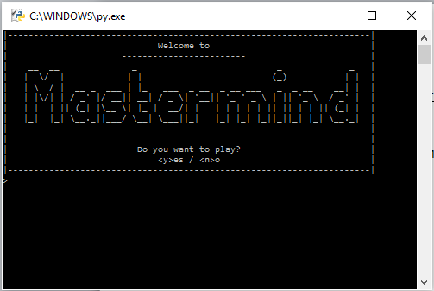1.

(1) To play, please type *yes* or *y*. If you do not wish to play, please type *no* or *n*. Then press enter.

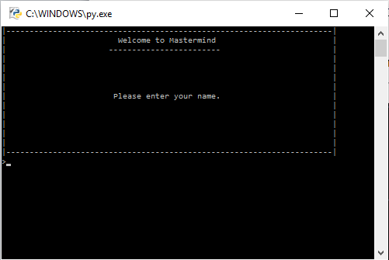2.

(2) Please enter your desired username, then press enter.

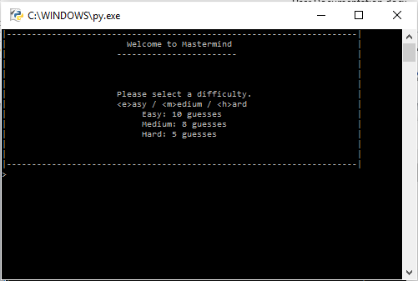3.

(3) You will then be brought to a difficulty selection screen. Each difficulty has a differing number of allotted guesses. Please type in your desired difficulty, or its first letter and press enter.

E.g. *easy* or *e*

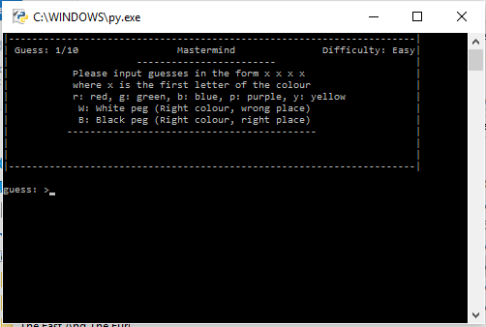4.

(4) Pictured above is the game’s main interface. Note in the top left is your guess number and the number of allotted guesses (determined by difficulty). In the top right is your difficulty setting. The text centred describes the rules of the game, how to input your guesses, the colours to guess from and the meaning of the resulting pegs.

E.g. If the code to guess was **b g r r** (blue, green, red, red) and you guessed **p p y b** (purple, purple, yellow, blue), your resulting pegs would be **W** (white peg) because you have guessed one correct colour, in the wrong location.

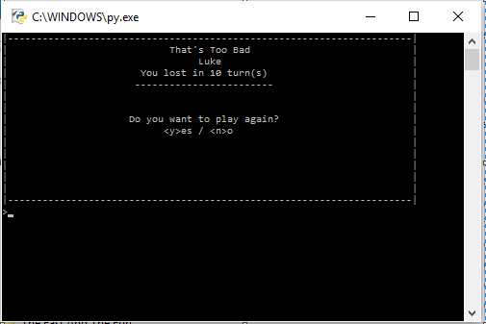5.

(5) If you are not successful in guessing the code in the allotted turns, you will be presented with the above game over screen. To play again, type *yes* or *y*. To quit, type *no* or *n*.

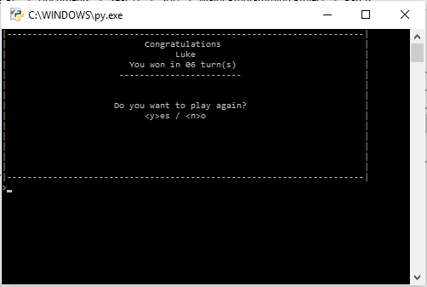6.

(6) If you are successful at guessing the code in the allotted turns, you will be presented with the above game over screen. To play again, type *yes* or *y*. To quit, type *no* or *n*.

FAQ / Troubleshooting

1. *The game won’t run on my computer.*

If the game does not work, you may lack the required prerequisite software. Please ensure that you have Python 3.x.x installed on your machine before attempting to run Mastermind.

1. *There isn’t any colour in Mastermind.*

This is a limitation of the command-line interface used in this game. Please use your imagination for the colours.

1. *The game is too difficult.*

Think through each guess. Every guess counts towards your discovery of the code. Focus on the repeating pegs throughout your guesses to determine each colour’s location.

1. *The font size is too small.*

The font size of the program is determined by your operating system’s terminal’s default font size. Please change your terminal’s font size to change the font size in Mastermind.

1. *My name is too long for a username.*

Mastermind supports usernames up to 60 characters in length. If your name exceeds this limit, please use a nickname or shortened name for your username.

Installation Guide

Please note on the Mastermind disc, there should be 2 files: Mastermind.py and User Manual.docx. The first file is the application file. The second is a user manual, including various useful information. It is recommended to read this manual before playing.

**To install:**

1. Copy Mastermind.py to any location on your computer. *Recommended – C:\Program Files\Mastermind*
2. The game is now installed.